**Yaniv Suriyano HeartMe ❤ install flow.**

Hi, don’t worry the installation is very easy (we will do it together) 😊.

1. First of all check if you have an Android Studio if not you can download it by the link below.a

[Android Studio download link](https://developer.android.com/studio?gclid=EAIaIQobChMIqImMgbbv8AIVtRoGAB2UZAHcEAAYASAAEgLXpPD_BwE&gclsrc=aw.ds)

1. Select “Standart” for the “Install Type” inside the wizard.
2. 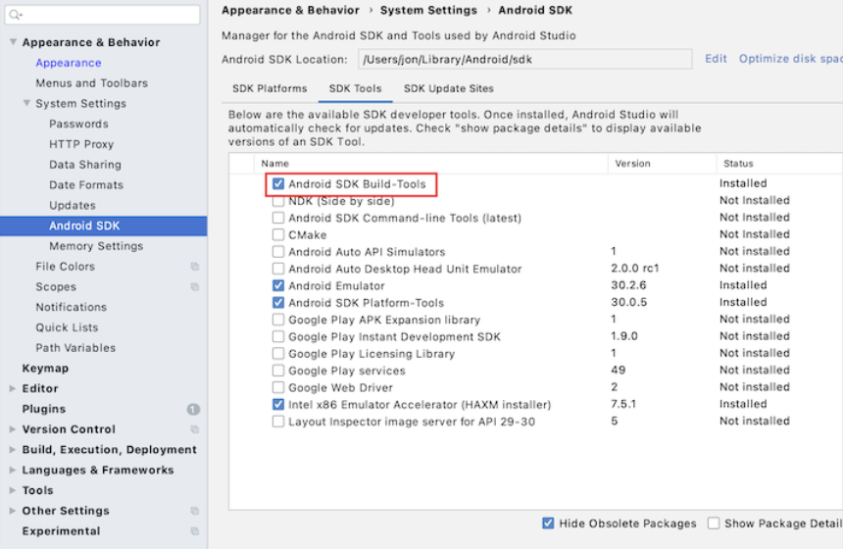Inside the Android Studio go to Preference 🡪 Appearance & behavior 🡪 System Settings 🡪 Android SDK and click on the “SDK Tools” and make sure you have at leat one version of the “Android SDK build-tools”

## 

1. 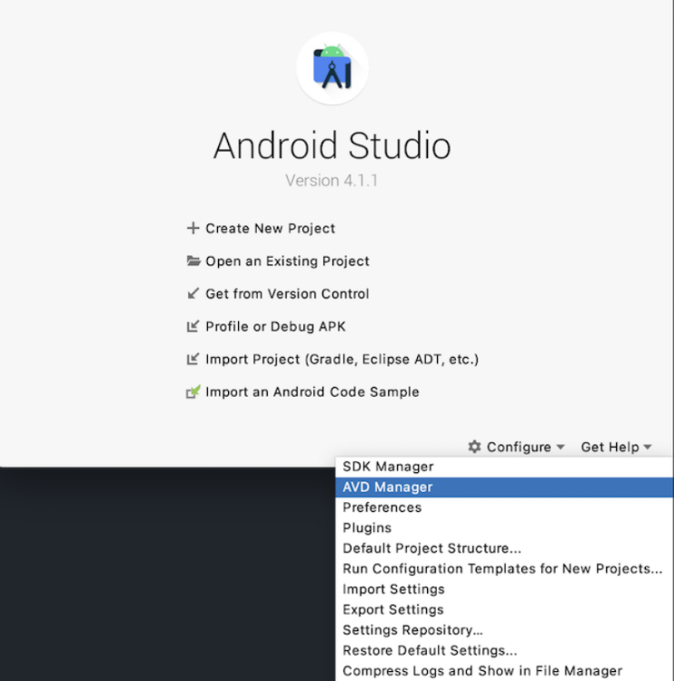On the Android Studio main screen, click “Configure” 🡪 “AVD Manager” in the dropdown.
2. Press the + button to create virtual Device.

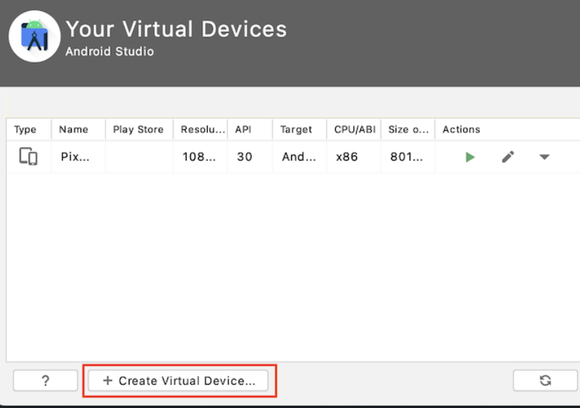

1. Choose the type of hardware you’d like to emulator ( I choose for pixel 4 but you can choose anything else).
2. 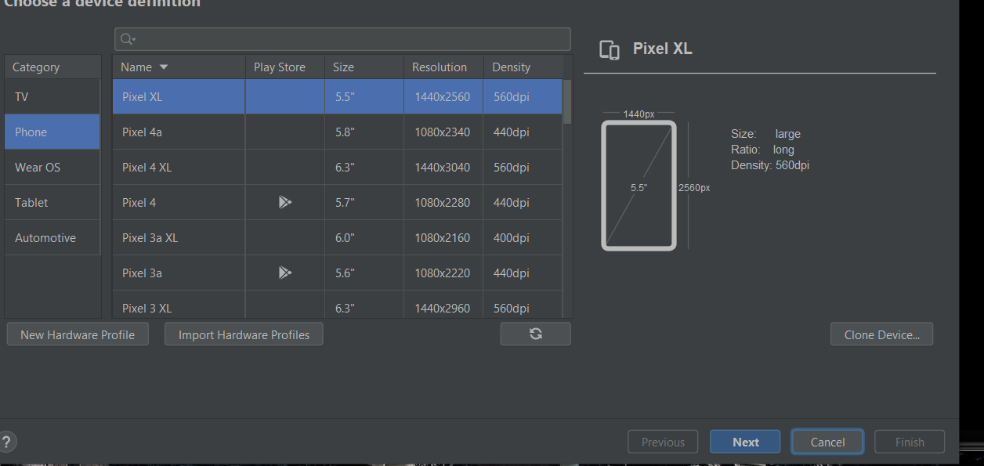Click next 🡪 next 🡪 Finish .
3. 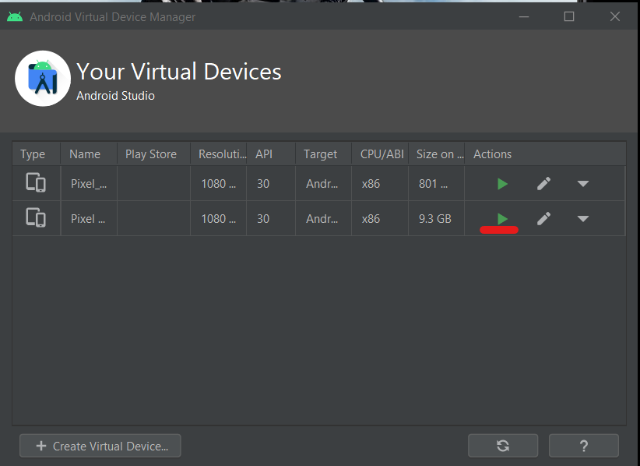And for startup click on the ‘Play’ on the virtual devices menu.

Now when you finish your installation now we need to clone the code from Github and put it on VS Code.

[ReactNativeTestChecker Download](ReactNativeTestChecker%20Download)

1. 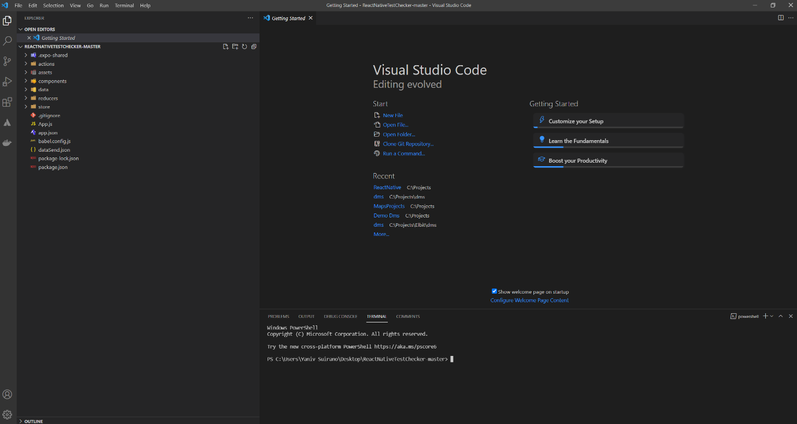Open the zip file to folder and open up the folder by VS code.
2. On the terminal write “npm install” 🡪 Enter and wait ‘til the installation is finish.

3) When everthing is done in the terminal write ‘Npm Start’ .

4) When the npm start finish to load the project he will open up automatically the browser.

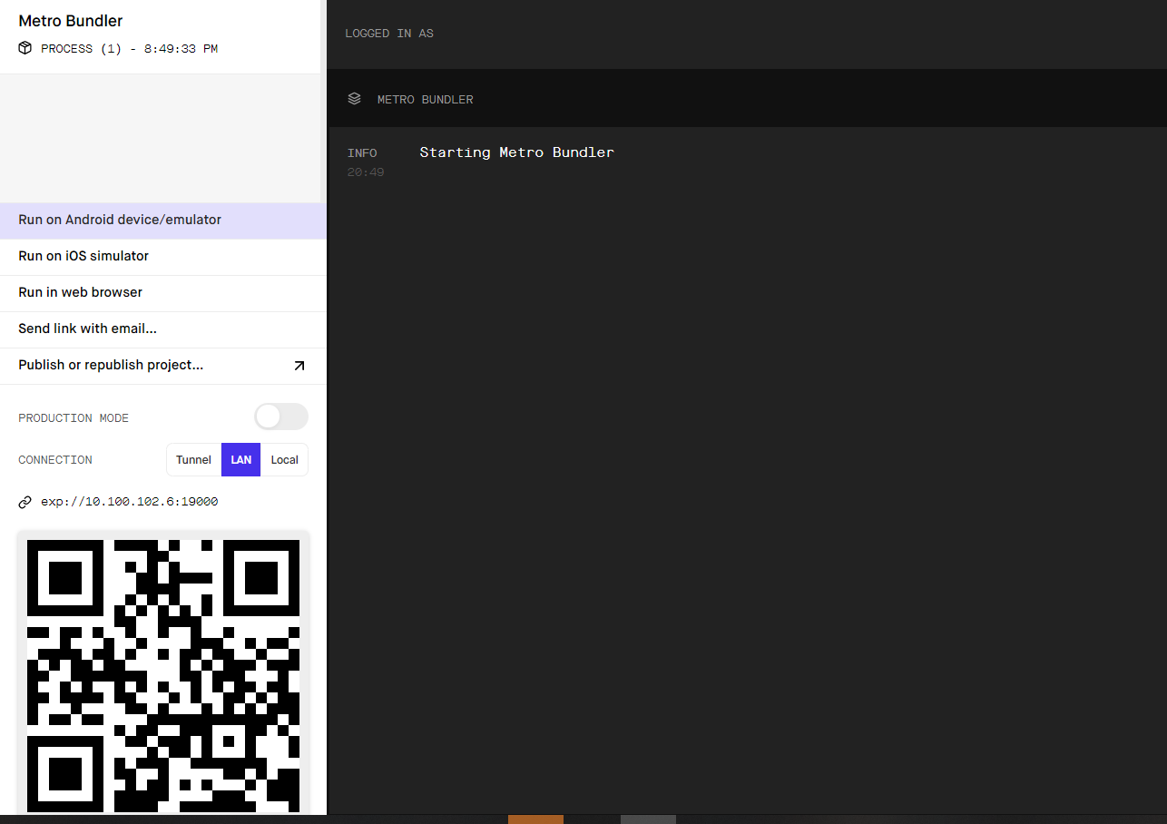

5) let’s get back to Android Studio to AVD Manager screen and click ‘Play’ to run the phone simulator

6) When the phone stated up Click on ‘run on android device / Emulator’ on the browser and wait….

After few seconds you should see the project on the emulator screen.

(If its you first time Its can take a 2 -3 mins to run the emulator).

Have Fun 😊

